To upgrade Advantage Licence
Help Note
Draft 1.0 – 19/10/2022 – John knighton
John.knighton@mentorbs.com

Contents
Overview 0
To stop the Advantage Database Server Service. 0
Run ADS Stamp utility 0

Overview
Below is the process to update the user count in Advantage
N.B. This procedure needs to be performed on the CASH server that is hosting the database, ensure everyone is logged out of Cash and the Mentor Communication Server (MCS) MCSTCPIP and Insync is stopped.

To stop the Advantage Database Server Service.
Navigate to - C:\Program Files\Advantage (Version Number) \Server or wherever the Advantage Server is installed.
Double click on - ads_cfg.exe and select Stop Service
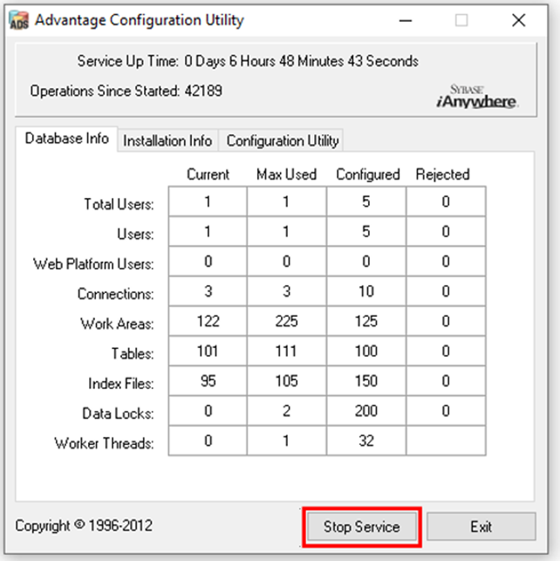

Run ADS Stamp utility
Navigate to - C:\Program Files\Advantage (Version Number) \Server or wherever the Advantage Server is installed.
Double click on - adsstamp.exe
Select – Licence
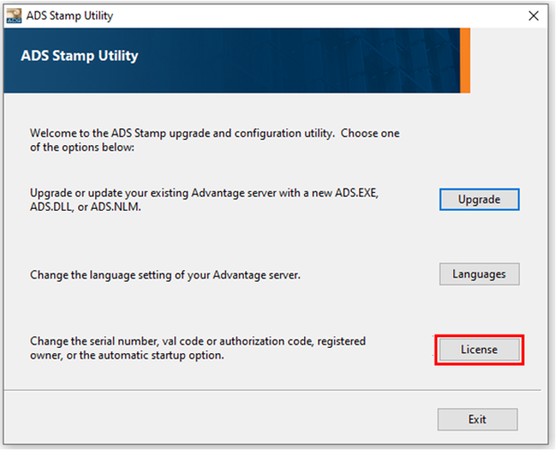
Enter the Serial number and Validation code.
Click - Next.
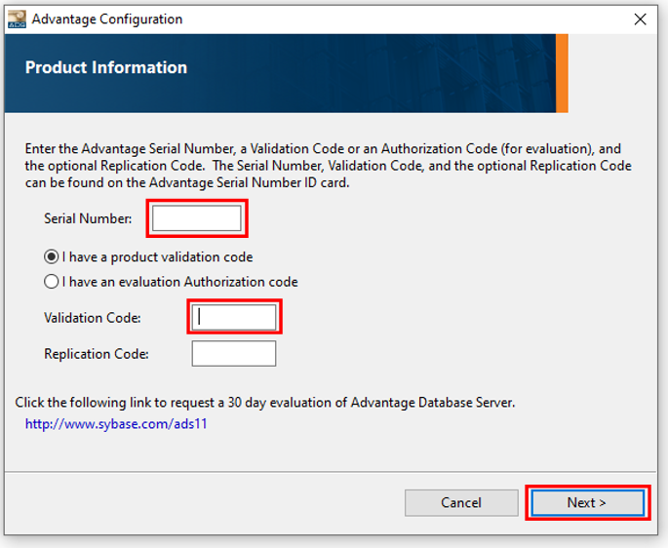
Check - Your Company name is the registered owner.
Ensure that Automatic Startup is selected
Click - Next.
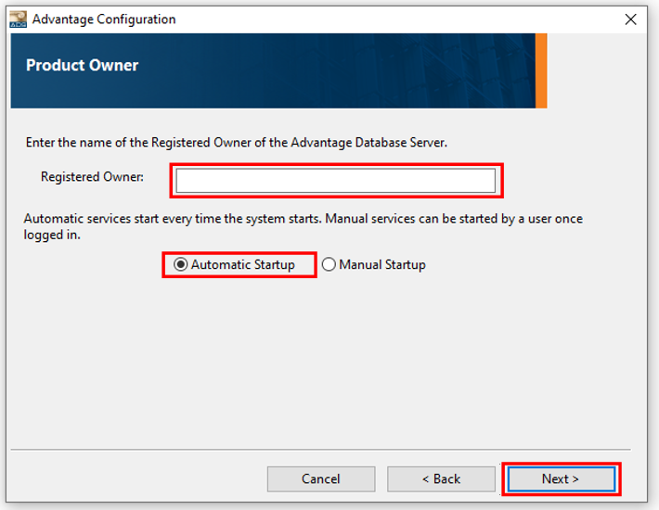
Select – Exit
